**INSTALLION MANUAL**

**PICTURERAMA**

**Version 1.0**



Team 12

Table of content

Cloning the project 3

Importing and opening the project with IntelliJ 4

Fixing modules 8

Setting up the Database 10

You can find a video tutorial for this manual by following this link: <https://youtu.be/5MvVc33qKwY>

## Cloning the project

We assume you have IntelliJ IDEA installed on your computer, as well as downloaded Java 12 SDK.

Make sure you have installed git on your computer. If you have not done it yet, you can download git by following this link: <https://git-scm.com/downloads>

After you have installed git, navigate to or create a folder on your computer you want to save the project in. Right click inside the folder with your mouse and click on “Git Bash Here” (for Windows) or “open a new terminal here” (for Mac). A terminal should show up (*Screenshot 1)*.

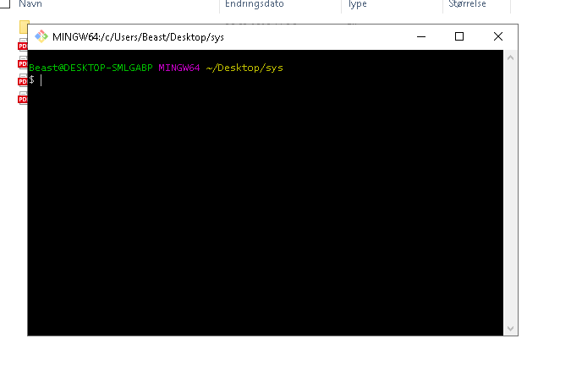

Screenshot 1

Copy this command: ***git clone*** [***https://gitlab.stud.idi.ntnu.no/gruppe-12/picturerama.git***](https://gitlab.stud.idi.ntnu.no/gruppe-12/picturerama.git)

and paste it inside the terminal by right clicking in the terminal and then clicking “Paste” or “Paste into the terminal”. Click “Enter” and wait for the terminal to stop printing out text. The terminal should have displayed a message saying “100%, done”. It should look something like *Screenshot 2*.

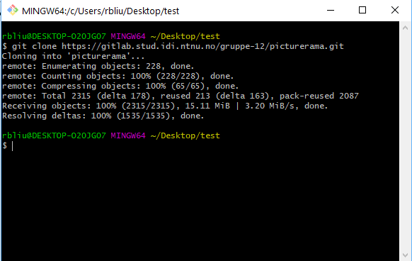

Screenshot 2

You can now exit the terminal by clicking on the exit button in the top right corner or typing “exit” and pressing “Enter”.

## Importing and opening the project with IntelliJ

You have now cloned the project and you can open it in IntelliJ. On IntelliJ’s main window click “Open or Import”, or “Import Project” for older versions of IntelliJ (*Screenshot 3*).

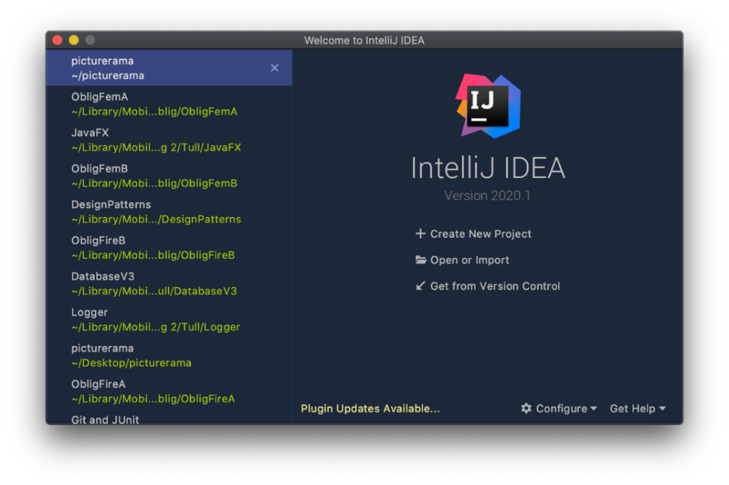

Screenshot 3

Afterwards, navigate to the folder where you cloned the project to. Inside that folder there should now be a new folder called “picturerama”. Choose the “picturerama” folder and click OK. IntelliJ should then open the project.

Some older versions of IntelliJ require extra steps for importing the project. If a new window like in *Screenshot 4* pops up, follow these steps from here. If the project opens up without any extra windows, you can skip this “Fixing modules” section on page 8.

In this new window, choose “Import project from external model” at the top, select Maven and click “Next” (*Screenshot 4*).

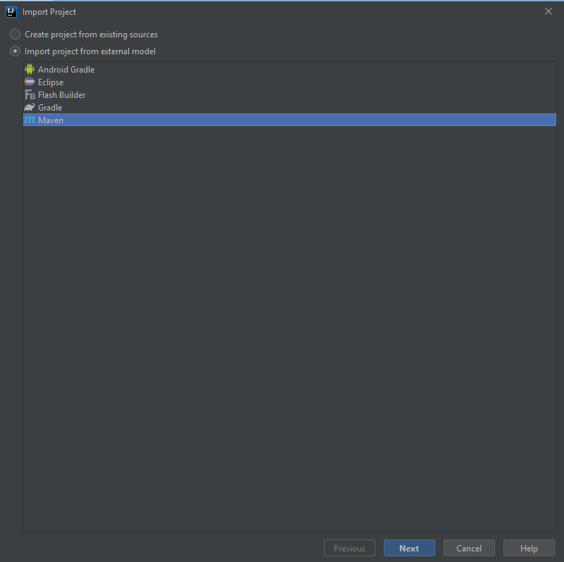

Screenshot 4

A new window shows up. Do not change anything and click “Next”. Now you should see a window saying “Select Maven projects to import”. Make sure “12:Picturerama:1.0 is checked and click “Next” (*Screenshot 5*).

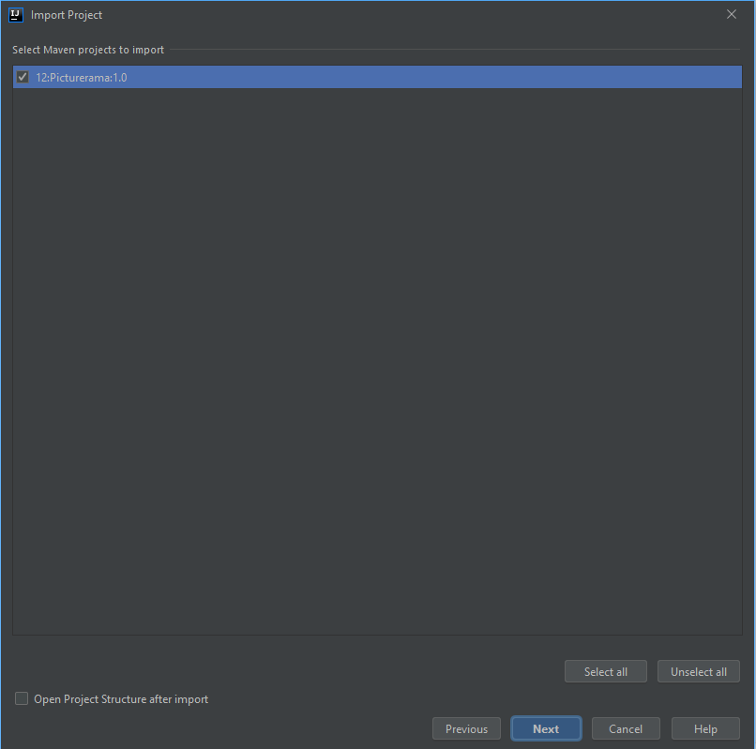

Screenshot 5

Select Java SDK 12 from the list on the left. If you can’t find it in the list, click on “Add New SDK” button (marked as a plus sign), click on “JDK”, navigate to the folder where you have installed Java JDK 12 and click “OK”. When you have selected Java SDK 12 (*Screenshot 6*), click “Next”.

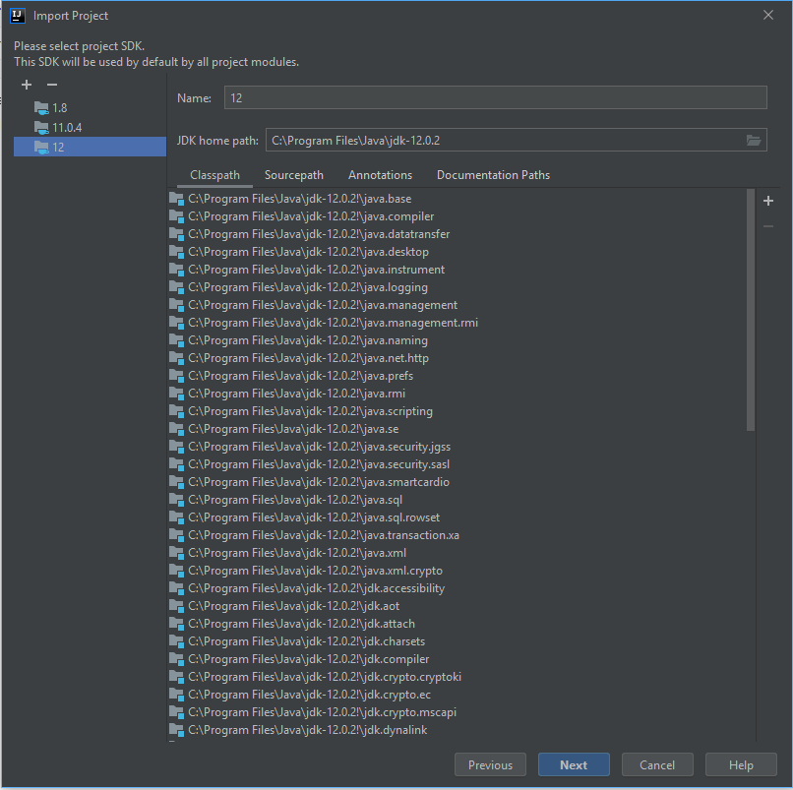

Screenshot 6

Do not change the name or file location, just click “Finish” and IntelliJ should open the project.

## Fixing modules

To make sure you see Maven resolving dependencies, navigate and open the *pom.xml* file in the project, right click in it, go down to Maven and click “Reimport” (*Screenshot 7*).

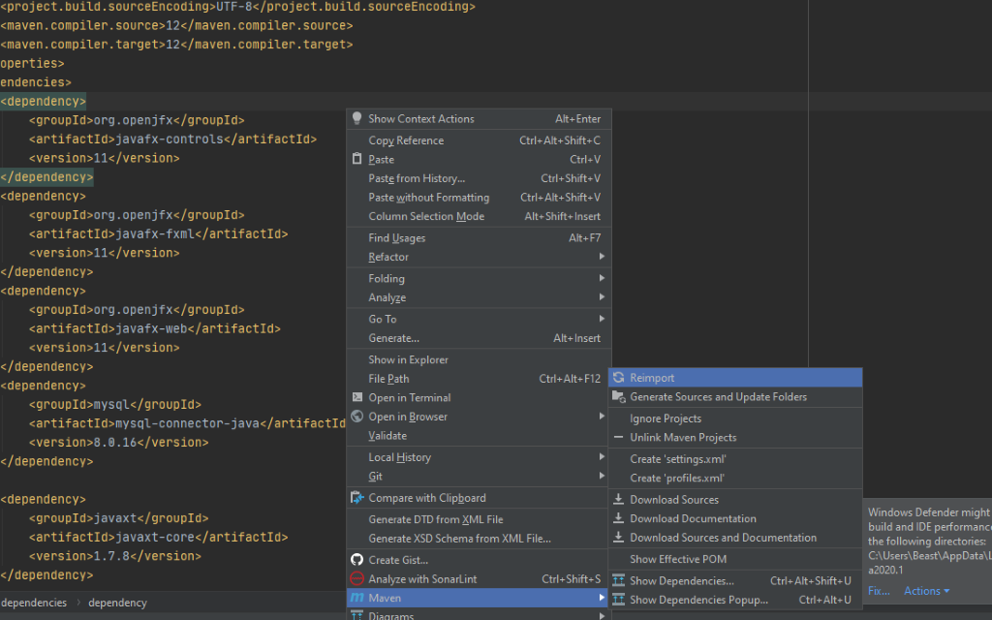

Screenshot 7

Now navigate to Project Structure by clicking on File -> Project Structure.

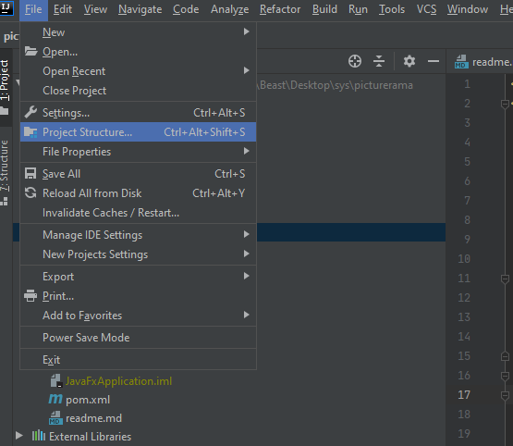

Screenshot 8

Navigate to Modules. Click on the little arrow next to “src” folder to expand the folder. Likewise expend the “main” folder. Select the folder named “App” and click on “Sources” button above where it says “Mark as”. The “App” folder icon should turn to blue color. Now select the “Test” folder and click on “Tests” button above. The icon next to the folder should turn to green color. It should look like it is shown in *Screenshot 9* bellow. If it does, click “Apply” and OK.

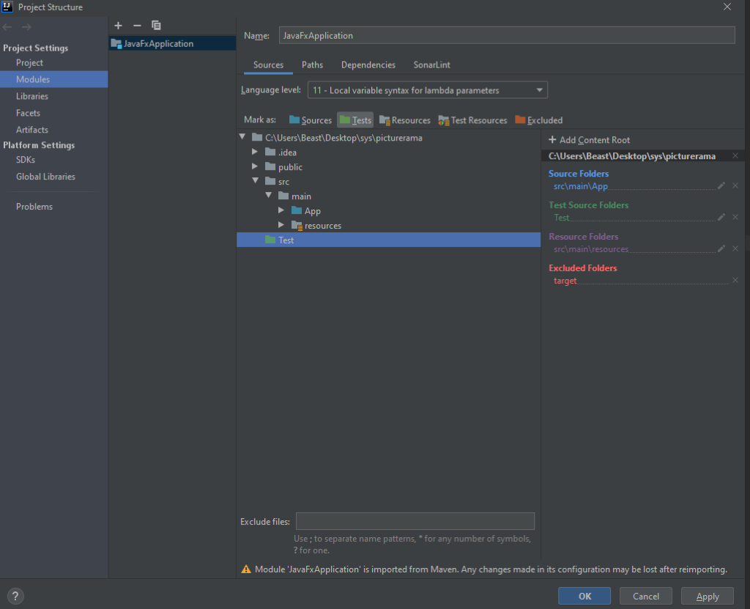

Screenshot 9

## Setting up the Database

Follow the readme.md file under “Installing” on GitLab to setup the database:

<https://gitlab.stud.idi.ntnu.no/gruppe-12/picturerama/-/blob/dev/readme.md>

Starting the App

Step 1)

Go to View -> Tool Windows -> Maven or click Maven on the right side of the IntelliJ window, as shown with the red arrows in *Screenshot 10* bellow. Maven tool window should pop out.

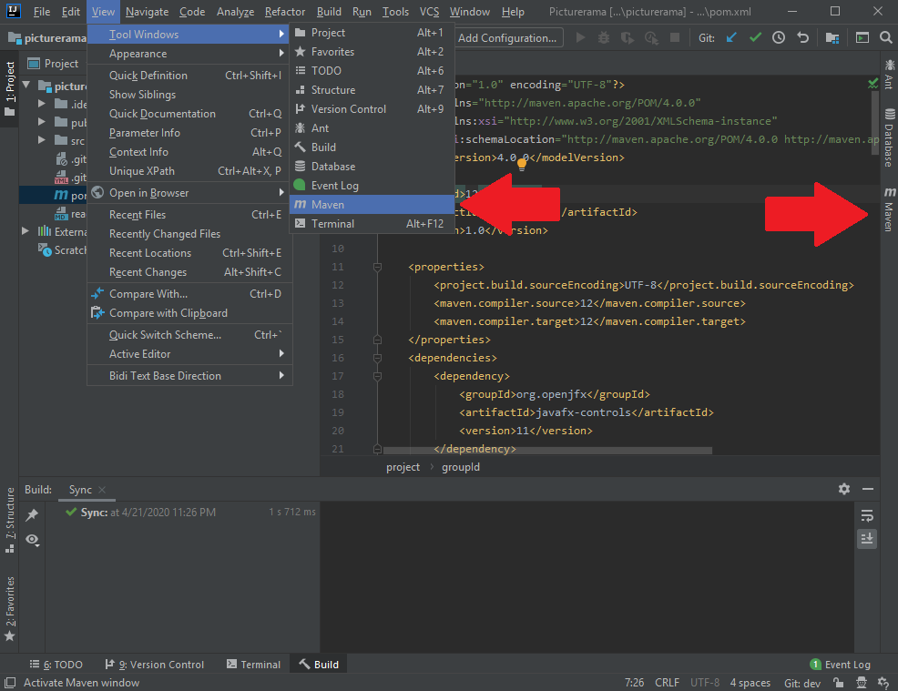

Screenshot 10

Step 2)

To run the program, you first need to compile it with Maven JavaFX. Locate the JavaFX compiler plugin (javafx:compile) under Plugins -> javafx (*Screenshot 11*), and either double-left-click it or right-click it and click on “Run Maven Build”. Wait for it to finish compiling and then click the green hammer (Build Project) at the top in IntelliJ. Wait for the build to finish.

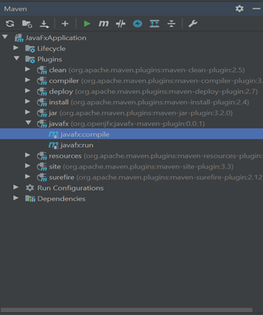

Screenshot 11

Finally, right click javafx:run and click “Run Picturerama” like in *Screenshot 12* (it might also say “Run unnamed”). This will set your run button in IntelliJ to run the project automatically with that Maven plugin. Therefore, you can now use the play button in IntelliJ to easily run the project.

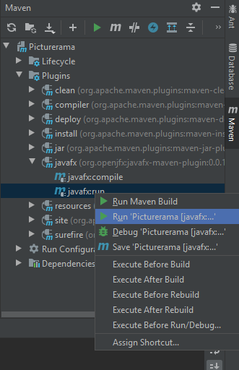

Screenshot 12